Basic Queries

Samantha Krall

SYM-400

SELECT \* FROM Sales.Store

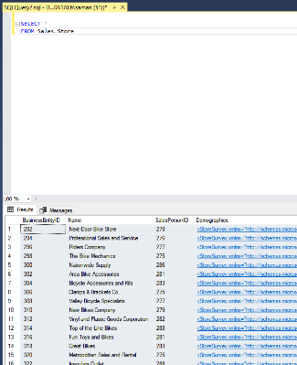

SELECT \* FROM Sales.CreditCard

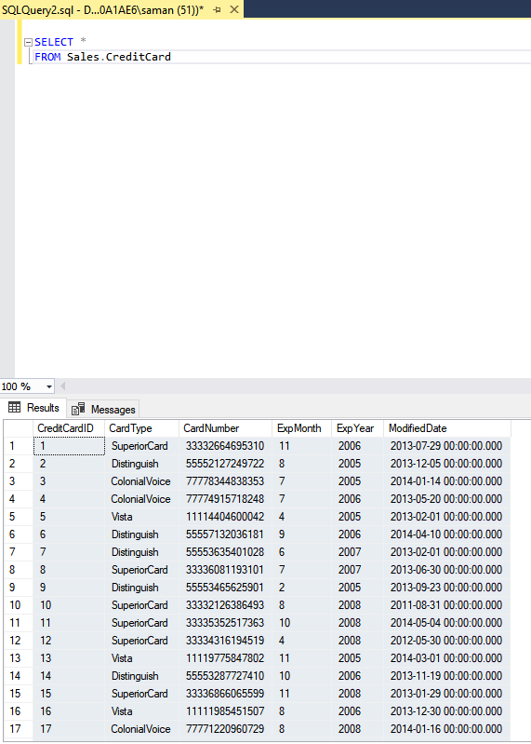

How many records are there in the Sales.Store table?

There are seven hundred and one records. 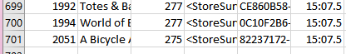

What kind of information is contained in the Sales.Store table? What columns are contained on the Sales.Store table?

The columns are BusinessEntityID, Name, SalesPersonID, Demographics, rowguid and ModifiedDate. The information is the basic information for the stores contained in the Sales database.

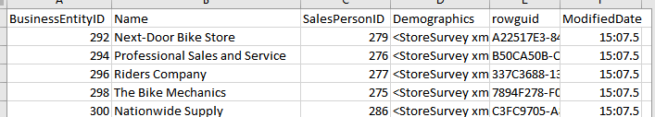

What is the Expiration year of Credit Card ID #13?

2005



In the CreditCard table, how would you expand the second query to determine all the cards of type “SuperiorCard”?

SELECT \*

FROM Sales.CreditCard

WHERE CardType = ‘SuperiorCard’

